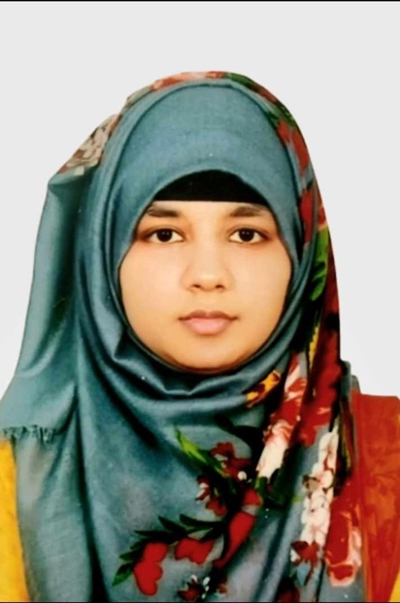

**TAZRINA AKTER SHUBRA**

UTTARA, DHAKA-1230

BANGLADESH

01719593393

Tazrina.shubra@gmail.com



PROFESSIONAL SUMMARY

Exploring myself to achieve my goals and motivated accounting professional ready to build long-term career with growing team. Focused on maintaining accurate, compliant records and controls responsive to dynamic operating conditions.

ACADEMIC BACKGROUND

**Bachelor of Business Administration**

**Independent University, Bangladesh(IUB)**

DHAKA, BANGLADESH

2021-Current

HSC - Business studies

MILESTONE COLLEGE

UTTARA , DHAKA , BANGLADESH

2020

WORK EXPERIENCE

**Accountant Snigdho Fashion House | DHAKA, Bangladesh**

**January 2021 - March 2022**

* As an Accountant I helped to make financial decisions by collecting, tracking, and correcting the company's finances.
* Prepared quarterly tax returns and reviewed submitted documentation with auditors.
* Accurately performed daily cash functions, including A/P and A/R tracking, budgeting, payroll transactions, expense management and various reconciliations.

SKILLS

* Microsoft Word, PowerPoint, Excel
* Decision-making
* Teamwork and collaboration
* Goal and conversion tracking
* Written and verbal communication

HOBBIES

* Art & Drawing
* Gardening
* Collecting stones